***Solution*** ***Section* 4.1 – Parameterizations of Plane Curves**

***Exercise***

Give parametric equations and parameter intervals for the motion of a particle in the *xy*-plane. Identify the particle’s path by finding a Cartesian equation for it. Graph the Cartesian equation.

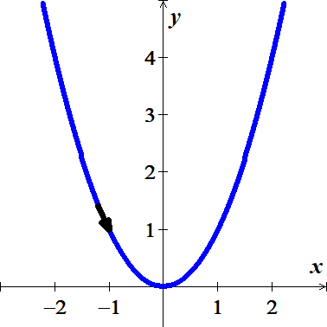

***Solution***







 

***Exercise***

Give parametric equations and parameter intervals for the motion of a particle in the *xy*-plane. Identify the particle’s path by finding a Cartesian equation for it. Graph the Cartesian equation.

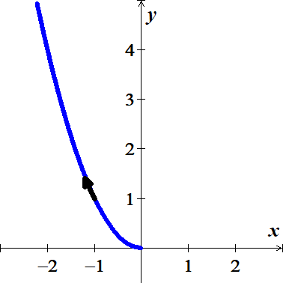

***Solution***







***Exercise***

Give parametric equations and parameter intervals for the motion of a particle in the *xy*-plane. Identify the particle’s path by finding a Cartesian equation for it. Graph the Cartesian equation.

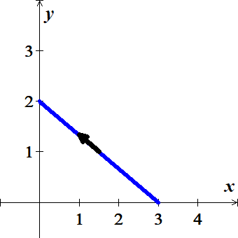

***Solution***









 

***Exercise***

Give parametric equations and parameter intervals for the motion of a particle in the *xy*-plane. Identify the particle’s path by finding a Cartesian equation for it. Graph the Cartesian equation.

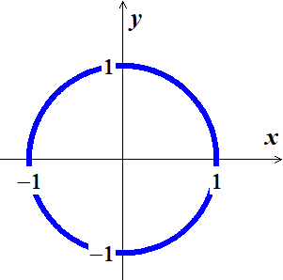

***Solution***





∴ Unit circle centered at the origin.

***Exercise***

Give parametric equations and parameter intervals for the motion of a particle in the *xy*-plane. Identify the particle’s path by finding a Cartesian equation for it. Graph the Cartesian equation.

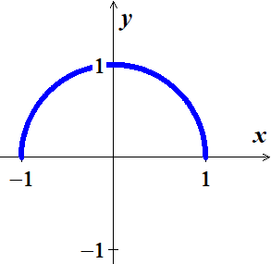

***Solution***





∴ Semi−circle centered at the origin with radius 1.

***Exercise***

Give parametric equations and parameter intervals for the motion of a particle in the *xy*-plane. Identify the particle’s path by finding a Cartesian equation for it. Graph the Cartesian equation.

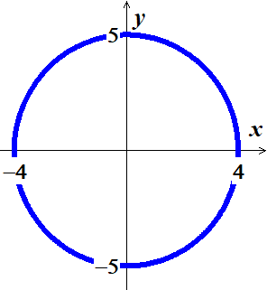

***Solution***





 

***Exercise***

Give parametric equations and parameter intervals for the motion of a particle in the *xy*-plane. Identify the particle’s path by finding a Cartesian equation for it. Graph the Cartesian equation.



***Solution***







∴ Circle centered at  with radius 1.

***Exercise***

Give parametric equations and parameter intervals for the motion of a particle in the *xy*-plane. Identify the particle’s path by finding a Cartesian equation for it. Graph the Cartesian equation.



***Solution***







***Exercise***

Give parametric equations and parameter intervals for the motion of a particle in the *xy*-plane. Identify the particle’s path by finding a Cartesian equation for it. Graph the Cartesian equation.



***Solution***















***Exercise***

Give parametric equations and parameter intervals for the motion of a particle in the *xy*-plane. Identify the particle’s path by finding a Cartesian equation for it. Graph the Cartesian equation.



***Solution***





***Exercise***

Give parametric equations and parameter intervals for the motion of a particle in the *xy*-plane. Identify the particle’s path by finding a Cartesian equation for it. Graph the Cartesian equation.

 

***Solution***









***Exercise***

Give parametric equations and parameter intervals for the motion of a particle in the *xy*-plane. Identify the particle’s path by finding a Cartesian equation for it. Graph the Cartesian equation.



***Solution***





The equation represents a circle with a center at origin of radius 4.

|  |  |
| --- | --- |
| ***t*** |  |
| 0 |  |
|  |  |
| 0.25 |  |
| 0.5 |  |
| 0.75 |  |
| 1 |  |

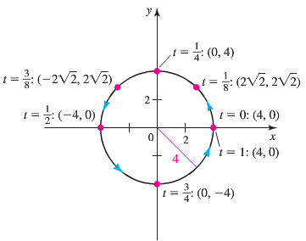

***Exercise***

Give parametric equations and parameter intervals for the motion of a particle in the *xy*-plane. Identify the particle’s path by finding a Cartesian equation for it. Graph the Cartesian equation.



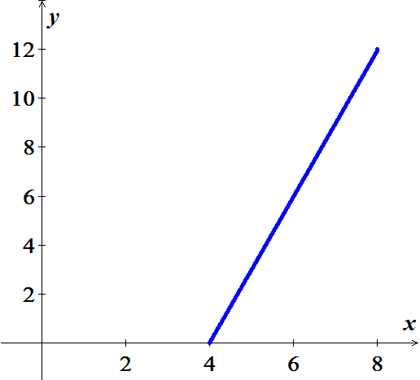***Solution***





 (***Line***)

***Exercise***

Give parametric equations and parameter intervals for the motion of a particle in the *xy*-plane. Identify the particle’s path by finding a Cartesian equation for it. Graph the Cartesian equation.

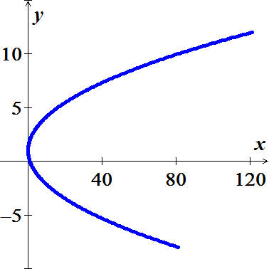 

***Solution***







***Exercise***

Give parametric equations and parameter intervals for the motion of a particle in the *xy*-plane. Identify the particle’s path by finding a Cartesian equation for it. Graph the Cartesian equation.

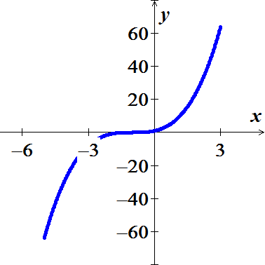 

***Solution***





***Exercise***

Give parametric equations and parameter intervals for the motion of a particle in the *xy*-plane. Identify the particle’s path by finding a Cartesian equation for it. Graph the Cartesian equation.



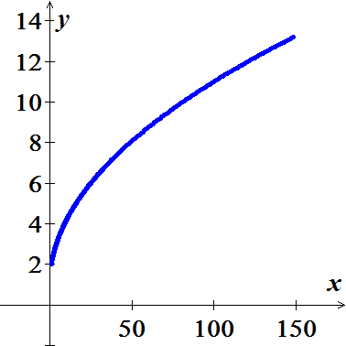***Solution***





***Exercise***

Give parametric equations and parameter intervals for the motion of a particle in the *xy*-plane. Identify the particle’s path by finding a Cartesian equation for it. Graph the Cartesian equation.

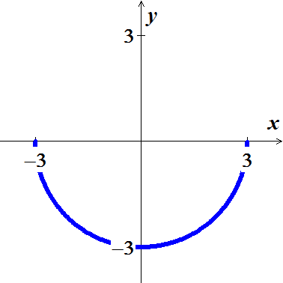 

***Solution***







 

∴ The equation represents a semi-circle with a center at origin of radius 3.

***Exercise***

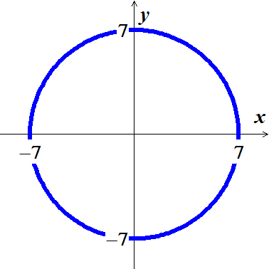Give parametric equations and parameter intervals for the motion of a particle in the *xy*-plane. Identify the particle’s path by finding a Cartesian equation for it. Graph the Cartesian equation.



***Solution***









∴ The equation represents a circle with a center at origin of radius 7.

***Exercise***

Give parametric equations and parameter intervals for the motion of a particle in the *xy*-plane. Identify the particle’s path by finding a Cartesian equation for it. Graph the Cartesian equation.



***Solution***

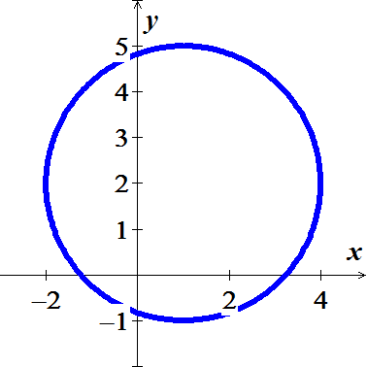







∴ The equation represents a circle with a center at  of radius 7.

***Exercise***

Give parametric equations and parameter intervals for the motion of a particle in the *xy*-plane. Identify the particle’s path by finding a Cartesian equation for it. Graph the Cartesian equation.

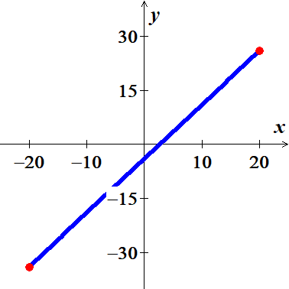

***Solution***









∴ The equation represents a segment line .

***Exercise***

Give parametric equations and parameter intervals for the motion of a particle in the *xy*-plane. Identify the particle’s path by finding a Cartesian equation for it. Graph the Cartesian equation.

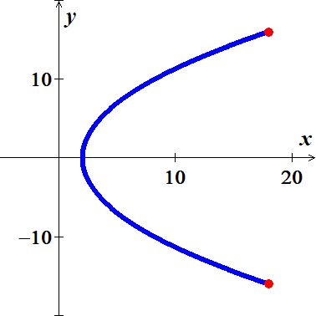

***Solution***









∴ The equation represents a parabola.

***Exercise***

Give parametric equations and parameter intervals for the motion of a particle in the *xy*-plane. Identify the particle’s path by finding a Cartesian equation for it. Graph the Cartesian equation.

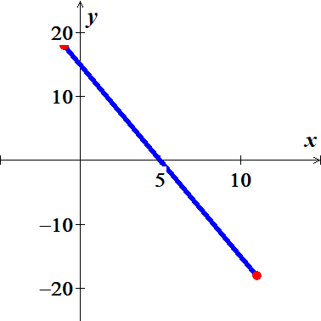

***Solution***











∴ The equation represents a segment line .

***Exercise***

Give parametric equations and parameter intervals for the motion of a particle in the *xy*-plane. Identify the particle’s path by finding a Cartesian equation for it. Graph the Cartesian equation.



***Solution***





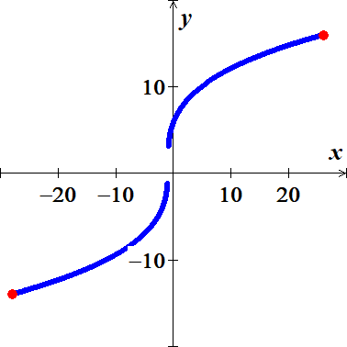





***Exercise***

Give parametric equations and parameter intervals for the motion of a particle in the *xy*-plane. Identify the particle’s path by finding a Cartesian equation for it. Graph the Cartesian equation.



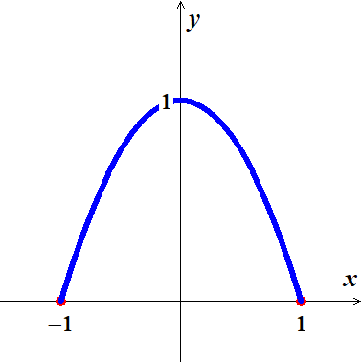***Solution***











∴ The equation represents a parabola.

***Exercise***

Give parametric equations and parameter intervals for the motion of a particle in the *xy*-plane. Identify the particle’s path by finding a Cartesian equation for it. Graph the Cartesian equation.



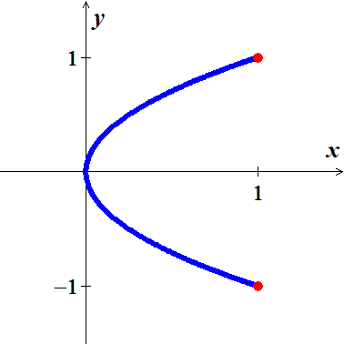***Solution***













∴ The equation represents a parabola.

***Exercise***

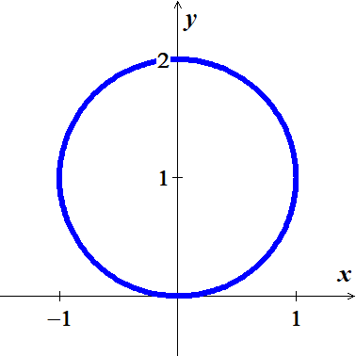Give parametric equations and parameter intervals for the motion of a particle in the *xy*-plane. Identify the particle’s path by finding a Cartesian equation for it. Graph the Cartesian equation.



***Solution***











∴ Circle centered at  with radius 1.

***Exercise***

Give parametric equations and parameter intervals for the motion of a particle in the *xy*-plane. Identify the particle’s path by finding a Cartesian equation for it. Graph the Cartesian equation.



***Solution***





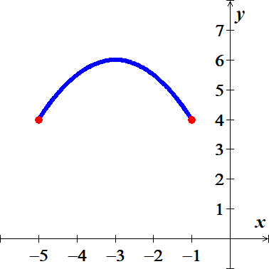 





















***Exercise***

Give parametric equations and parameter intervals for the motion of a particle in the *xy*-plane. Identify the particle’s path by finding a Cartesian equation for it. Graph the Cartesian equation.



***Solution***



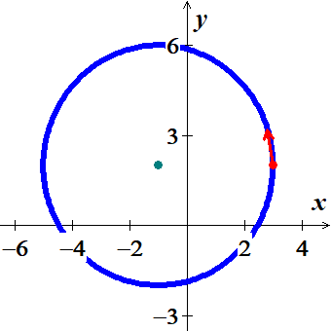













∴ Circle centered at  with radius 4.

***Exercise***

For the given parametric equations: 

1. Plot the following curve, indicating the positive orientation.
2. Eliminate the parameter to obtain an equation in x and y.
3. Identify or briefly describe the curve.
4. Evaluate  at the specified point.

***Solution***

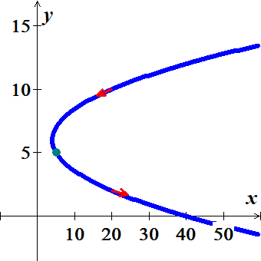

1. 







1. 



The curve is parabola with vertex at 

1. 











***Exercise***

For the given parametric equations: 

1. Plot the following curve, indicating the positive orientation.
2. Eliminate the parameter to obtain an equation in x and y.
3. Identify or briefly describe the curve.
4. Evaluate  at the specified point.

***Solution***

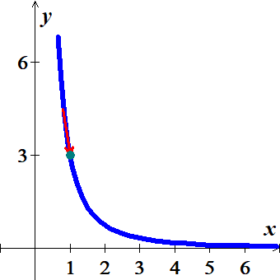

1. 











1. The curve represents the proportional of the function  with 
2. 





***Exercise***

For the given parametric equations: 

1. Plot the following curve, indicating the positive orientation.
2. Eliminate the parameter to obtain an equation in x and y.
3. Identify or briefly describe the curve.
4. Evaluate  at the specified point.

***Solution***

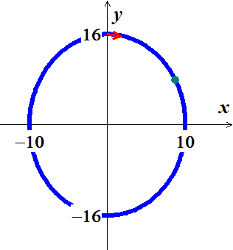

1. 









1. The curve represents an ellipse traced clockwise.
2. 









***Exercise***

For the given parametric equations: 

1. Plot the following curve, indicating the positive orientation.
2. Eliminate the parameter to obtain an equation in x and y.
3. Identify or briefly describe the curve.
4. Evaluate  at the specified point.

***Solution***

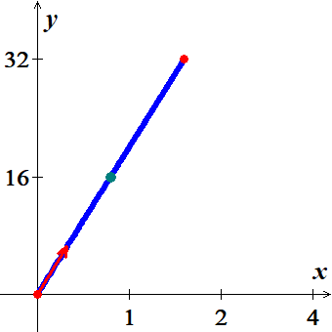

1. 







1. The curve represents a line from point  to .
2. 



 

***Exercise***

Find parametric equation for the left half of the parabola , originating at 

***Solution***

Let  for 

***Exercise***

Find parametric equation for the line that passes through the points  and , oriented in the direction of increasing *x*.

***Solution***

 









***Exercise***

Find parametric equation for the lower half of the circle centered at  with radius 6, oriented in the counterclockwise direction.

***Solution***





 since it oriented in *ccw* direction and lower half, therefore, *y*-value has to be negative.



***Exercise***

Find parametric equation for the upper half of the parabola , originating at 

***Solution***

Let 

***Exercise***

Find parametric equation for a circle centered at the origin with radius 4, generated counterclockwise.

***Solution***





***Exercise***

Find parametric equation for a circle centered at the origin with radius 12, generated clockwise with initial point 

***Solution***





***Exercise***

Find parametric equation for a circle centered at  with radius 1, generated counterclockwise.

***Solution***







***Exercise***

Find parametric equation for a circle centered at  with radius 3, generated clockwise.

***Solution***







***Exercise***

Find parametric equation for a circle centered at  with radius 8, generated clockwise.

***Solution***







***Exercise***

Find parametric equation for the circle , generated clockwise.

***Solution***



***Exercise***

Find parametric equation for the upper half of the ellipse , generated counterclockwise.

***Solution***



***Exercise***

Find parametric equation for the right side of the ellipse , generated counterclockwise.

***Solution***



***Exercise***

Find parametric equation for the line 

***Solution***

Let 





***Exercise***

Find parametric equation for the line segment from  to  and the line segment from *Q* to *P*.

***Solution***

Line segment from  to 







Let 





Line segment from  to 











***Exercise***

Find parametric equation for the segment of the curve  from  to 

***Solution***

Let 









***Exercise***

What is the relationship among *a, b, c*, and *d* such that the equations

 describe a circle?

What is the radius of the circle?

***Solution***

















If 







Where 





Where 













The radius of the circle:





***Exercise***

Find parametric equations (not unique) of an ellipse centered at the origin with major axis of length 6 on the  and minor axis of length 3 on the , generated counterclockwise. Graph the ellipse and find a description in terms of *x* and *y*.

***Solution***

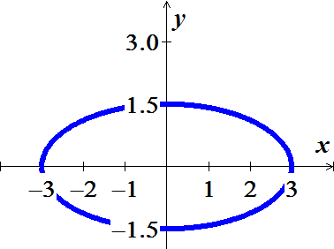







***Exercise***

Find parametric equations (not unique) of an ellipse centered at the origin with major axis of length 12 on the  and minor axis of length 2 on the , generated clockwise. Graph the ellipse and find a description in terms of *x* and *y*.

***Solution***

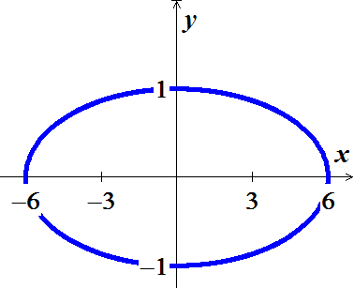







***Exercise***

Find parametric equations (not unique) of an ellipse centered at  with major and minor axes of lengths 30 and 20, parallel to the  and , respectively. Graph the ellipse and find a description in terms of *x* and *y*.

***Solution***

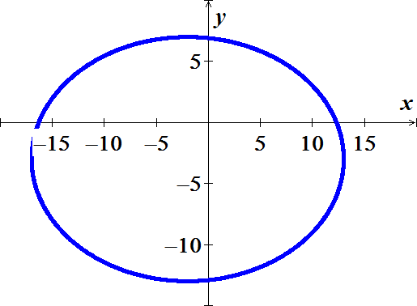







***Exercise***

Find a parametric equations and a parameter interval for the motion of a particle starting at the point (2, 0) and tracing the top half of the circle  four times.

***Solution***

The top half of the circle: 



***Exercise***

Find a parametrization for the line segment joining points (0,2) and (4, 0) using the angle *θ* in the accompanying figure as the parameter.

***Solution***

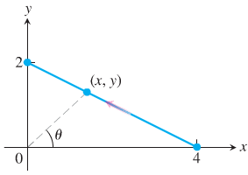

Slope: 



The equation of the line passing thru (0,2) and (4, 0):

















***Exercise***

Find a parametrization for the circle  starting at (1, 0) and moving counterclockwise to the terminal point (0, 1), using the angle *θ* in the accompanying figure as the parameter.

***Solution***





The equation of the circle is given by: 





































At the point (0, 1):









***Exercise***

A common task is to parameterize curves given either by either Cartesian equations or by graphs. Find a parametric representation of the following curves.

1. The segment of the parabola 
2. The complete curve 
3. The piecewise linear path that connects  to  to  (in that order), where the parameter varies over the interval 

***Solution***

1. Let  for 

Which represents a parabola

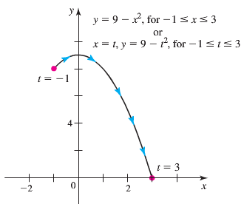

1. Let 

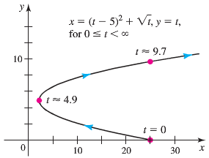

1. The path consists of 2−line segments that can be parameterized separately. 

The line segment *PQ*:

 





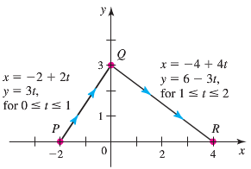



The line segment *QR*:

 









***Exercise***

A projectile launched from the ground with an initial speed of 20 *m/s* and a launch angle *θ* follows a trajectory approximated by



Where *x* and *y* are the horizontal and vertical positions of the projectile relative to the launch point .

1. Graph the trajectory for various of *θ* in the range .
2. Based on your observations, what value of *θ* gives the greatest range (the horizontal distance between the launch and landing points)?

***Solution***

1. 

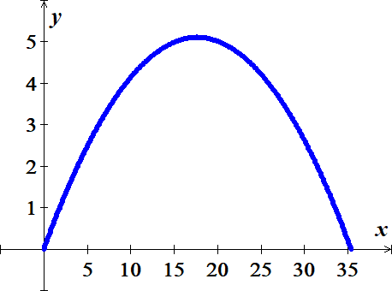



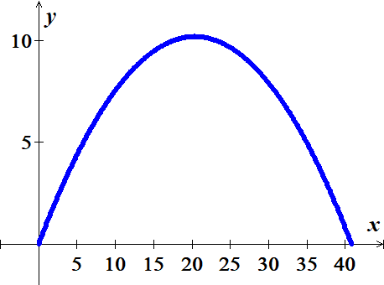



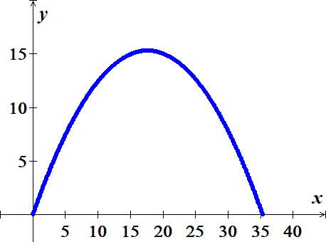

1. The greatest range occurs when 

***Exercise***

Many fascinating curves are generated by points on rolling wheels. The path of a light on the rim of a rolling when is a cycloid, which has the parametric equations



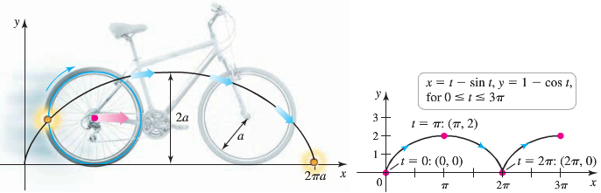

Where . Graph the cycloid with . On what interval does the parameter generate one arch of the cycloid?

***Solution***

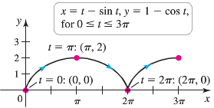

The wheel completes one full revolution on the interval , which gives one arch of the cycloid.

***Exercise***

Find parametric equations that describe the circular path of the objects. Assume  denotes the position of the object relative to the origin at the center of the circle.

A go-cart moves counterclockwise with constant speed around a circular track of radius 400 *m*, completing in 1.5 *min*.

***Solution***

Let *t* be time in minute, so 



Since 



The path is a circle of radius 400, center at origin and the circle is traversed counterclockwise.

***Exercise***

Find parametric equations that describe the circular path of the objects. Assume  denotes the position of the object relative to the origin at the center of the circle.

The tip of the 15-*in* second hand of a clock completes one revolution in 60 *sec*.

***Solution***

Let *t* be time in second, so 



Since 







The path is a circle of radius 15, center at origin and the circle is traversed clockwise.

***Exercise***

Find parametric equations that describe the circular path of the objects. Assume  denotes the position of the object relative to the origin at the center of the circle.

A Ferris wheel has a radius of 20 *m* and completes a revolution in the clockwise direction at constant speed in 3 *min*. Assume that *x* and *y* measure the horizontal and vertical positions of a seat on the Ferris wheel relative to a coordinate system whose origin is at the low point of the wheel. Assume the seat begins moving at the origin.

***Solution***

Let *t* be time in minute, so 

Since the low point is the origin, the circle has its center at  and a radius of 20.



Since 



The path is a circle of radius 20, center at .

***Exercise***

A plane traveling horizontally at 80 *m/s* over flat ground at an elevation of 3000 *m* releases an emergency packet. The trajectory of the packet is given by



Where the origin is the point on the ground directly beneath the plane at the moment of the release. Graph the trajectory of the packet and find the coordinates of the point where the packet lands.

***Solution***

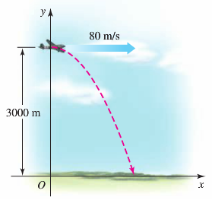The packet hits ground when:







And 





***Exercise***

A plane traveling horizontally at 100 *m/s* over flat ground at an elevation of 4,000 *m* must drop an emergency packet on a target on the ground. The trajectory of the packet is given by



Where the origin is the point on the ground directly beneath the plane at the moment of the release.

How many horizontal meters before the target should the packet be released in order to hit the target?

***Solution***

 when the packet hits the ground

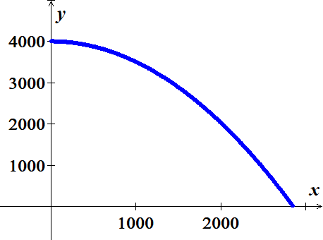















***Exercise***

The path of a point on circle *A* with radius  that rolls on the inside of circle *B* with a radius *a* is an asteroid or hypocycloid. Its parametric equations are



Graph the asteroid with  and find its equation in terms of *x* and *y*.

***Solution***









 

